**AIRLINE MANGAMENT SYSTEM**

**A MINI-PROJECT REPORT**

***Submitted by***

# Chandeep roshen 2116220701050

Charan Jeeth 2116220701052

***in partial fulfilment of the award of the degree***

***of***

# BACHELOR OF ENGINEERING

**IN**

## COMPUTER SCIENCE AND ENGINEERING



**RAJALAKSHMI ENGINEERING COLLEGE**

**AUTONOMOUS, CHENNAI**

# NOV/DEC, 2023

## BONAFIDE CERTIFICATE

Certified that this mini project **“AIRLINE MANAGEMENT SYSTEM**” is the bonafide work of “**Chandeep roshen(2116220701050) and Charan Jeeth (2116220701052)”** who carried out the project work under my supervision.

**SIGNATURE**

**Mrs. JANANEE V,**

Assistant Professor,

Computer Science & Engineering

Rajalakshmi Engineering College Thandalam, Chennai -602105.

Submitted for the End semester practical examination to be held on

**INTERNAL EXAMINER EXTERNAL EXAMINER**

## ACKNOWLEDGEMENT

I express my sincere thanks to my beloved and honorable chairman **MR.S.MEGANATHAN** and the chairperson **DR.M.THANGAM MEGANATHAN** for their timely support and encouragement.

I am greatly indebted to my respected and honorable principal **Dr. S.N.MURUGESAN** for his able support and guidance.

No words of gratitude will suffice for the unquestioning support extended to us by my head of the department **Dr. P. KUMAR,** and my Academic Head **Dr.N.DURAIMURUGAN,** for being ever supporting force during my project work.

I also extend my sincere and hearty thanks to my internal guide **Mrs.**

**JANANEE V** and **Mrs. BHAVANI M** for her valuable guidance and motivation during the completion of this project.

My sincere thanks to my family members, friends and other staff

members of Computer Science and Engineering.

Chandeep roshen 2116220701050 Charan Jeeth 2116220701052

ABSTRACT :-

The Airline Management System (AMS) is a comprehensive software application designed to automate and streamline the operations of an airline. It integrates various functions including flight scheduling, ticket reservations, passenger management, inventory control, and financial transactions, thereby enhancing the efficiency of airline operations. The system allows customers to search for flights, book tickets, and manage their bookings through a user-friendly interface. For airline staff, the AMS facilitates real-time tracking of flight statuses, passenger check-in, and baggage handling, while also enabling seamless coordination between different departments such as marketing, operations, and customer service.

The core features of the system include an online booking platform, an automated payment gateway, a database for storing passenger and flight details, a dynamic ticketing module, and a robust reporting system. By improving operational efficiency, reducing manual errors, and enhancing customer experience, the Airline Management System plays a pivotal role in the competitive aviation industry. Additionally, it supports decision-making processes through comprehensive data analytics and reporting tools, providing key insights into customer preferences, financial trends, and operational performance.

In essence, the Airline Management System aims to optimize day-to-day operations, improve customer satisfaction, and boost the overall profitability of airline companies by offering a unified, integrated platform for managing airline activities.

# TABLE OF CONTENTS

**CHAPTER TITLE PAGE**

**NO. NO**

**ABSTRACT 4**

1. **INTRODUCTION 6**
   1. INTRODUCTION 6
   2. SCOPE OF THE WORK 6
   3. PROBLEM STATEMENT 6
   4. AIM AND OBJECTIVES OF THE 7

PROJECT

1. **SYSTEM SPECIFICATIONS 8**
   1. HARDWARE SPECIFICATIONS 8
   2. SOFTWARE SPECIFICATIONS 8
2. **ARCHITECTURE DIAGRAM 9**
3. **MODULE DESCRIPTION 10**
4. **SYSTEM DESIGN 11**
   1. USECASE DIAGRAM 11
   2. E-R MODEL 12
   3. DATAFLOW DIAGRAM 13
   4. ACTIVITY DIAGRAM 15
5. **CODING 18**
6. **SCREENSHOTS 20**
7. **CONCLUSION 26 REFERENCES** 27

CHAPTER 1 : -

* 1. Introduction

The Airline Management System (AMS) is a sophisticated software solution designed to optimize and automate the day-to-day operations of an airline. As the aviation industry becomes increasingly complex, airlines face numerous challenges, including managing flight schedules, coordinating reservations, handling passenger services, tracking inventory, and ensuring compliance with regulatory standards. The AMS addresses these challenges by providing an integrated platform that streamlines these processes and enhances operational efficiency.

* 1. Scope of Work

The scope of work for an **Airline Management System (AMS)** involves the development, deployment, and integration of various components that address both the operational and customer-facing aspects of airline management. This system aims to enhance efficiency, streamline processes, and improve user experience by automating tasks, centralizing data, and providing real-time updates.

* 1. Problem Statement

The aviation industry is complex, involving numerous operational processes that must be efficiently managed to ensure smooth functioning. Traditional methods of managing airline operations—such as manual record-keeping, fragmented systems, and reliance on paper-based transactions—often lead to inefficiencies, increased human error, delays, and poor customer satisfaction. Airlines face significant challenges in handling various functions, including flight scheduling, ticket booking, passenger management, crew assignments, inventory management, and customer support. These issues not only affect operational efficiency but also result in higher costs, poor service quality, and reduced profitability.

* 1. Aim and Objective

**Aim:**

The aim of the **Airline Management System (AMS)** is to develop an integrated, automated platform that optimizes the core operations of an airline, improves efficiency, enhances customer satisfaction, and provides real-time data and insights for better decision-making. The system will streamline all aspects of airline management, from flight scheduling and reservations to crew management, ticketing, customer service, and financial reporting, ensuring a seamless, efficient, and cost-effective operation.

**Objectives:**

1. **Streamline Flight Scheduling and Reservation Management:**
   * Automate the scheduling of flights, manage seat allocations, and ensure real-time updates of available seats.
   * Enable customers to book, modify, and cancel flight reservations seamlessly through an online booking system.
   * Provide real-time flight status and updates (delays, cancellations, gate changes) to passengers and staff.
2. **Enhance Customer Experience and Self-Service Capabilities:**
   * Develop an intuitive and user-friendly interface for passengers to book tickets, select seats, and check in online.
   * Enable passengers to access their booking history, manage flight preferences, and receive timely notifications regarding their flight status.
   * Provide self-service kiosks or mobile apps to improve check-in, boarding, and overall passenger handling at airports.

## CHAPTER 2

### SYSTEM SPECIFICATIONS

**2.1 HARDWARE SPECIFICATIONS**

Processor **:** Pentium IV Or Higher

Memory Size **:** 128 GB (Minimum)

HDD **:** 40 GB (Minimum)

**2.2 SOFTWARE SPECIFICATIONS**

Operating System **:** WINDOWS 10 AND PLUS

Front – End **:** HTML, CSS, JAVASCRIPT

Back – End **:** PHP, MYSQL

CHAPTER 3

Architecture Diagram :-

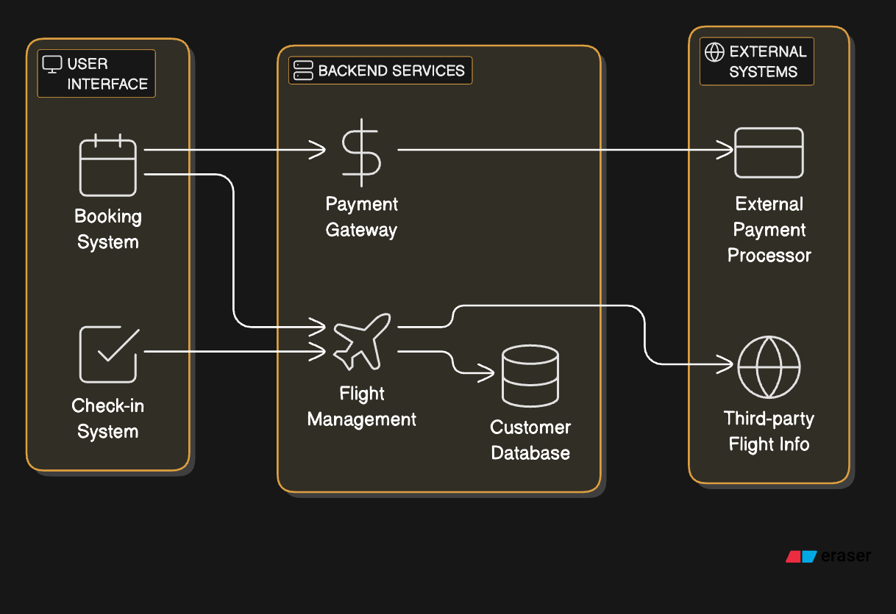

**CHAPTER 4**

### MODULE DESCRIPTION

**4.1. user Registration and Login Module:**

**1. Passenger Module**

**This module is designed for passengers to interact with the system for booking and managing their travel.**

* **User Registration/Login:**
  + **Sign up for new accounts.**
  + **Login and password recovery features.**
* **Flight Search & Booking:**
  + **Search for flights by destination, date, and other filters.**
  + **View flight details such as schedule, price, and class availability.**
  + **Book tickets and make payments.**
* **Booking Management:**
  + **View current bookings.**
  + **Modify or cancel bookings.**
  + **Upgrade seat class or add special requests (e.g., meals, extra baggage).**
* **Check-In:**
  + **Online check-in and seat selection.**
  + **Generate boarding passes.**
* **Notifications:**
  + **Receive email/SMS notifications for booking confirmation, flight status, and updates.**
* **Loyalty Program:**
  + **Earn and redeem frequent flyer points.**
  + **View loyalty status and benefits.**

**2. Admin Module**

**This module is for system administrators to manage the backend operations of the airline.**

* **User Management:**
  + **Manage passenger and staff accounts.**
  + **Approve or deactivate accounts.**
* **Flight Management:**
  + **Create and update flight schedules.**
  + **Monitor and manage flight statuses.**
* **Booking Oversight:**
  + **Monitor overall bookings.**
  + **Resolve payment or booking issues.**
* **Reports and Analytics:**
  + **Generate reports on sales, flight occupancy, and revenue.**
  + **Analyze performance metrics.**
* **Promotions and Discounts:**
  + **Create and manage promotional campaigns.**
  + **Apply discounts to flights.**

**3. Staff Module**

**This module helps airline staff, such as ground crew and flight attendants, perform operational tasks.**

* **Flight Schedule Access:**
  + **View assigned flights and schedules.**
  + **Track real-time flight statuses.**
* **Passenger Management:**
  + **Assist passengers with booking issues.**
  + **Manage check-in and boarding processes.**
* **Baggage Handling:**
  + **Track and manage passenger baggage.**
  + **Address lost or delayed baggage issues.**
* **In-flight Services:**
  + **View passenger special requests (e.g., meals, medical assistance).**
  + **Update service logs.**

**4. Guest Module**

**This module allows non-registered users to access limited functionalities.**

* **Flight Search:**
  + **Browse flight schedules and fares without logging in.**
* **Guest Booking:**
  + **Make bookings as a guest (with email/mobile for communication).**
* **Flight Status Tracking:**
  + **Check flight arrival/departure status.**

**5. Payment Module (Integrated)**

**A sub-module to manage financial transactions securely.**

* **Payment Processing:**
  + **Accept payments via credit cards, debit cards, e-wallets, and other methods.**
  + **Secure payment gateways.**
* **Refund Management:**
  + **Process refunds for cancellations or delays.**
* **Invoice Generation:**
  + **Generate and email payment receipts.**

**6. Customer Support Module**

**This module provides tools for assisting passengers with their concerns.**

* **Live Chat/Support Tickets:**
  + **Enable passengers to communicate with support teams.**
  + **Track and resolve issues via ticketing systems.**
* **FAQs and Knowledge Base:**
  + **Provide self-service help for common queries.**

**Chapter 5**

1. **Sequence diagram**

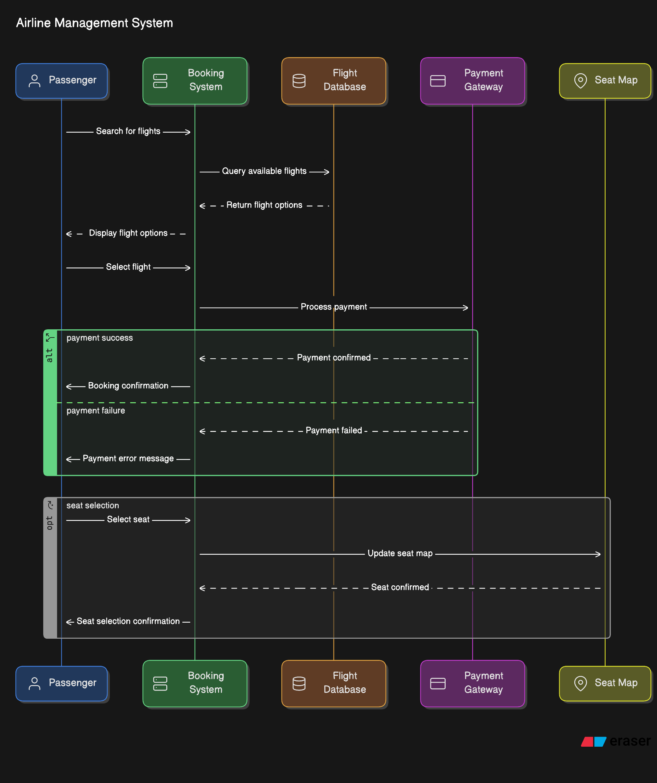

1. **ER Diagram**

1. **DFD**

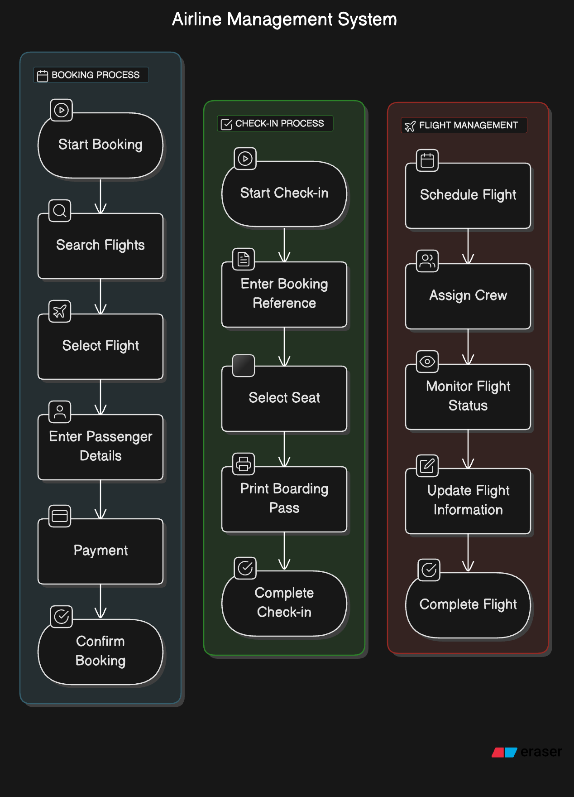

## CHAPTER 6

### SAMPLE CODING

<html>  
    <head>  
        <title>Login Handler</title>  
    </head>  
    <body>  
        <?php  
            session_start();  
            session_destroy();  
            session_start();  
            if(isset($_POST['Login']))  
            {  
                $data_missing=array();  
                if(empty($_POST['username']))  
                {  
                    $data_missing[]='Username';  
                }  
                else  
                {  
                    $user_name=trim($_POST['username']);  
                }  
                if(empty($_POST['password']))  
                {  
                    $data_missing[]='Password';  
                }  
                else  
                {  
                    $pass_word=$_POST['password'];  
                }  
                if(empty($_POST['user_type']))  
                {  
                    $data_missing[]='User Type';  
                }  
                else  
                {  
                    $user_type=$_POST['user_type'];  
                    $_SESSION['user_type']=$user_type;  
                }  
  
  
                if(empty($data_missing))  
                {  
                    if($user_type=='Customer')  
                    {  
                        require_once('../mysqli_connect.php');  
                        $query="SELECT count(*) FROM Customer where  
customer_id=? and pwd=?";  
                        $stmt=mysqli_prepare($dbc,$query);  
  
mysqli_stmt_bind_param($stmt,"ss",$user_name,$pass_word);  
                        mysqli_stmt_execute($stmt);  
                        mysqli_stmt_bind_result($stmt,$cnt);  
                        mysqli_stmt_fetch($stmt);  
                        //echo $cnt;  
                        mysqli_stmt_close($stmt);  
                        mysqli_close($dbc);  
                        /*$affected_rows=mysqli_stmt_affected_rows($stmt);  
                        $response=@mysqli_query($dbc,$query);  
                        echo $affected_rows;  
                        */  
                        if($cnt==1)  
                        {  
                            echo "Logged in <br>";  
                            $_SESSION['login_user']=$user_name;  
                            echo $_SESSION['login_user']." is logged in";  
                            header("location: customer_homepage.php");  
                        }  
                        else  
                        {  
                            echo "Login Error";  
                            session_destroy();  
                            header('location:login_page.php?msg=failed');  
                        }  
                    }  
                    else if($user_type=='Administrator')  
                    {  
                        require_once('../mysqli_connect.php');  
                        $query="SELECT count(*) FROM Admin where  
admin_id=? and pwd=?";  
                        $stmt=mysqli_prepare($dbc,$query);  
  
mysqli_stmt_bind_param($stmt,"ss",$user_name,$pass_word);  
                        mysqli_stmt_execute($stmt);  
                        mysqli_stmt_bind_result($stmt,$cnt);  
                        mysqli_stmt_fetch($stmt);  
                        //echo $cnt;  
                        mysqli_stmt_close($stmt);  
                        mysqli_close($dbc);  
                        /*$affected_rows=mysqli_stmt_affected_rows($stmt);  
                        $response=@mysqli_query($dbc,$query);  
                        echo $affected_rows;  
                        */  
                        if($cnt==1)  
                        {  
                            echo "Logged in <br>";  
                            $_SESSION['login_user']=$user_name;  
                            echo $_SESSION['login_user']." is logged in";  
                            header('location:admin_homepage.php');  
                        }  
                        else  
                        {  
                            echo "Login Error";  
                            session_destroy();  
                            header('location:login_page.php?msg=failed');  
                        }  
                    }  
                }  
                else  
                {  
                    echo "The following data fields were empty<br>";  
                    foreach($data_missing as $missing)  
                    {  
                        echo $missing ."<br>";  
                    }  
                }  
            }  
            else  
            {  
                echo "Submit request not received";  
            }  
        ?>  
    </body>  
</html>

Chapter 7 : -

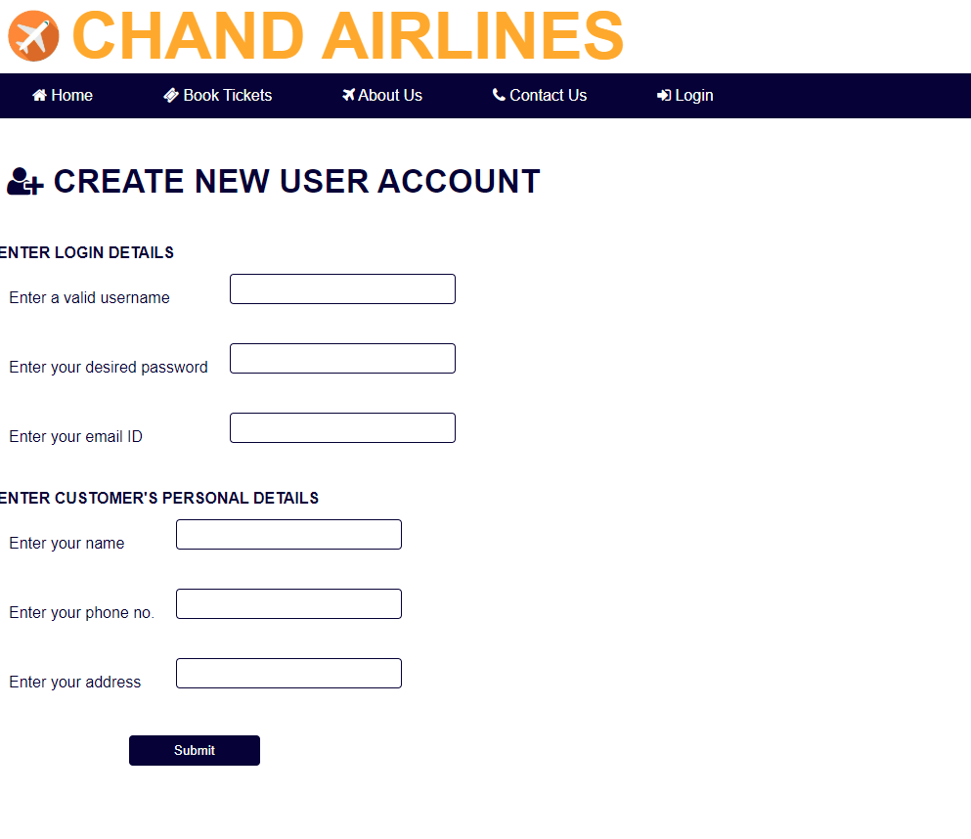

Conclusion:-

An airline management system is a comprehensive solution designed to streamline the operations of the airline industry, providing an efficient, user-friendly platform for passengers, staff, and administrators. By integrating various functionalities such as flight booking, scheduling, payment processing, and customer support into a centralized system, it improves operational efficiency, enhances customer satisfaction, and ensures seamless coordination among different departments.

The system offers the following benefits:

* **Enhanced Customer Experience:** Features like online booking, check-in, and real-time updates simplify the passenger journey and improve satisfaction.
* **Operational Efficiency:** Automation of flight schedules, crew management, and baggage handling reduces errors and speeds up processes.
* **Data-Driven Insights:** Real-time reporting and analytics help airlines make informed decisions, optimize routes, and maximize revenue.
* **Scalability and Adaptability:** Modular design ensures the system can evolve to meet future business needs and technological advancements.

In conclusion, a robust airline management system is not just a technological asset but a strategic tool for airlines to remain competitive, achieve operational excellence, and deliver exceptional service in the ever-evolving aviation industry.

Top of Form

Bottom of Form